**Objective question 2**

The 3rd Law of Newton defines any entity, broken or whole.

The force on the side of the locomotive is equal to that on the locomotive from the roof. A force on the portion of the wall that exploded was not necessary due to its framing around the wall.

The answer b

**Objective question 3**

A wind ride is a beautiful thing. This cancels the gravity of the Earth on the glider precisely to demonstrate free movement and to mimic the impact of distant space.

The answer b

**Objective question 6**

The linking rope m1 and m2 are assumed the continuous length, but both masses have a set distance (measured separate along the rope). Thus, their speeds must also be the same.

The answer a

**Problem 22**

Problem 22 is solved below in the picture

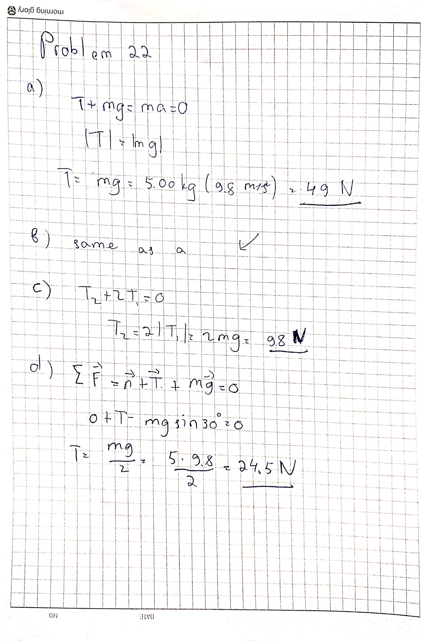

I am sorry if I’m late with the assignment.

Thank you

Student ID : 201923250

Name : Kobilov Ilkhomjon